Assignment 2 Report

Compiler Construction Lab

# Show error output:

Requirement: Make a new test to show the error output for ident too long

Here is the test example contains a long identification:

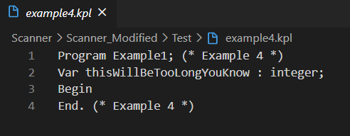

And the following is the output:

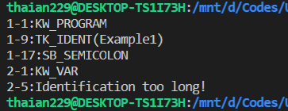

# Changing requirement:

Requirement: The language is case sensitive and all keywords are lowercase

## Solution:

To make it case sensitive, all we need to do is remove the uses of toUpper function in the keywordEq method inside token.c file.

And to change all keywords to lowercase, simply change all keywords in keywords array to lowercase.

## Implementation:

struct

{

    char string[MAX_IDENT_LEN + 1];

    TokenType tokenType;

} keywords[KEYWORDS_COUNT] = {

    // Change all keyword to lowercase to sastifies new requirement

    {"program", KW_PROGRAM},

    {"const", KW_CONST},

    {"type", KW_TYPE},

    {"var", KW_VAR},

    {"integer", KW_INTEGER},

    {"char", KW_CHAR},

    {"array", KW_ARRAY},

    {"of", KW_OF},

    {"function", KW_FUNCTION},

    {"procedure", KW_PROCEDURE},

    {"begin", KW_BEGIN},

    {"end", KW_END},

    {"call", KW_CALL},

    {"if", KW_IF},

    {"then", KW_THEN},

    {"else", KW_ELSE},

    {"while", KW_WHILE},

    {"do", KW_DO},

    {"for", KW_FOR},

    {"to", KW_TO}};

int keywordEq(char *kw, char *string)

{

    while ((*kw != '\0') && (*string != '\0'))

    {

        if (*kw != *string) // Now it's case sensitive

            break;

        kw++;

        string++;

    }

    return ((*kw == '\0') && (*string == '\0'));

}